

FINAL YEAR PROJECT REPORT

SEMESTER **EIGHT**

***SMART HELMET***

BY:

*AJAY BALAMI*

*(C30105210041)*

BACHELOR OF INFORMATION & COMMUNICATION TECHNOLOGY

SCHOOL OF SCIENCE & TECHNOLOGY

ASIA e UNIVERSITY

# DISCLAIMER

This Smart Helmet project has been developed solely for educational and personal research purposes. The design, features, and functionalities of the helmet are original and do not infringe upon any existing copyrights or intellectual property.

The creators of this project make no guarantees regarding the absolute accuracy, reliability, or effectiveness of the helmet's features in all conditions. While every effort has been made to ensure the quality and functionality of the device, the Smart Helmet is intended to be a prototype and should not be relied upon as a definitive safety device.

Users are responsible for using the device appropriately and maintaining it as required. The creators shall not be held liable for any damages, injuries, or losses arising from the use or misuse of the device. Always prioritize safety and follow applicable traffic laws and regulations.

This project is a demonstration of smart technology innovation and does not include any commercial intentions or guarantees for production-level quality.

Ajay Balami

__________

Jan 18 2025

# ACKNOWLEDGEMENT

I would like to express my sincere gratitude to all the individuals who have supported and guided me throughout the completion of this project, Smart Helmet: Enhancing Rider Safety with IoT Technology.

First and foremost, I am deeply indebted to my supervisor, **Mr. Ashish Koirala,** for his invaluable guidance, constructive feedback, and encouragement at every stage of this project. His expertise and dedication have been instrumental in shaping this work.

I would also like to extend my heartfelt thanks to the college administration and our coordinator, **Mr. Roshan KC**, for providing the necessary resources, support, and a conducive environment to pursue this endeavor.

A special mention goes to my dear friends, **Kiswor Chhetri** and **Devendra Kandel**, for their unwavering support, insightful suggestions, and assistance during challenging moments. Your camaraderie has been a source of great motivation.

Finally, I am profoundly grateful to all those who directly or indirectly contributed to this project’s success. Your encouragement and help have made this journey a rewarding and enriching experience.

Thank you all for your invaluable contributions.

Sincerely,

Ajay Balami

# ABSTRACT

The advancement of smart technologies has enabled the development of a Smart Helmet designed to enhance motorcycle rider safety. This helmet integrates various sensors and alert systems, addressing common causes of accidents. Key features include helmet detection to ensure the bike only starts when the helmet is worn correctly, alcohol detection to prevent riding under the influence, and fall detection with automatic emergency alerts. Additionally, obstacle and over-speeding alerts warn the rider of potential dangers, while engine overheating alerts prevent mechanical failures. An SOS button is included to send the rider's location as a message to a specified contact number through a mobile app in case of an emergency. Unlike existing smart helmets like Vata 7x1, Tali iTc, and Livall MC1 Pro, this helmet operates as a standalone safety device without the need for continuous mobile or web interfaces. By integrating these advanced features, the Smart Helmet aims to significantly reduce motorcycle-related risks and enhance rider safety.

**Keywords**: Smart Helmet, Wearable Technology, Road Safety, Rider Protection, IOT

TABLE OF CONTENTS

DISCLAIMER ii

ACKNOWLEDGEMENT iii

ABSTRACT iv

LIST OF FIGURES: vii

LIST OF TABLES: viii

LIST OF ABBREVIATIONS: ix

CHAPTER 1 INTRODUCTION 1

1.1 OVERVIEW 1

1.2 PROBLEM STATEMENT 2

1.3 OBJECTIVES 3

1.4 SCOPE 3

1.5 LIMITATIONS 4

1.6 TARGET USERS 5

1.7 PROJECT TIMELINE 5

CHAPTER 2 LITERATURE REVIEW 6

2.1 REVIEW OF EXISTING SYSTEM 6

2.1.1 Livall MC1 Pro Helmet 6

2.1.2 Tali iT C Smart Helmet 7

2.1.3 Vata 7x1 Smart Helmet 8

2.1.4 Sena Impulse Smart Helmet 9

2.2 LITERATURE REVIEW 10

2.2.1 Introduction 10

2.2.2 Development of Proposed System 10

2.2.3 Methodology 11

2.2.4 Comparison 12

CHAPTER 3 SYSTEM ANALYSIS 13

3.1 FUNCTIONAL REQUIREMENTS 13

3.1.1 Use Case Diagram 14

3.2 NON- FUNCTIONAL REQUIREMENTS 15

3.3 FEASIBILITY STUDY 16

3.3.1 Economic Feasibility 16

3.3.2 Operational Feasibility 17

3.3.3 Technical Feasibility 17

3.4 PROCESS MODELLING 19

3.4.1 Context Diagram 19

3.4.2 Data Flow Diagram 19

3.5 LOGIC MODELLING 20

3.5.1 Decision Table 20

3.5.2 Decision Tree 21

3.6 Class Diagram 22

CHAPTER 4 SYSTEM DESIGN 23

4.1 FLOWCHART 23

4.2 INPUT-OUTPUT DIAGRAM 24

4.3 SYSTEM ARCHITECTURE DIAGRAM 24

4.5 CIRCUIT DIAGRAM 25

4.5 TOOLS USED 26

4.5.1 Hardware Used 26

4.5.1.1 Microcontrollers and Sensors 26

4.5.1.2 Communication Module 26

4.5.1.3 User Interface Components 26

4.5.2 Software and Programming Tools 26

CHAPTER 5 IMPLEMENTATION AND TESTING 27

5.1 IMPLEMENTATION 27

5.2 TESTING 28

CHAPTER 6 CONCLUSION 30

6.1 CONCLUSION 30

6.2 FUTURE ENHACEMENT 31

6.3 REFERENCE 32

6.4 APPENDIX 33

6.4.1 Prototype Image 33

6.4.2 Circuit Board 35

6.4.2 Mobile App 36

## LIST OF FIGURES:

Figure 1: Timeline 5

Figure 2: Modular Development (Korkut, 2023) 11

Figure 3: Use Case Diagram 14

Figure 4*: Context* Diagram 19

Figure 5*:*Level*-1 DFD* 19

Figure 6*:* Level*-2 DFD* 19

Figure 7: Decision Tree 21

Figure 8: Class Diagram of Sender 22

Figure 9: Class Diagram of Receiver 22

Figure 10: Flowchart 23

Figure 11*:* Input-Output Diagram 24

Figure 12: System Architecture Diagram of Smart Helmet 24

Figure 13: Circuit Diagram for Sender 25

Figure 14: Circuit Diagram for Receiver 25

Figure 15: Prototyping in Breadboard 34

Figure 16: Circuit For Receiver 35

Figure 17: Circuit for Sender 35

Figure 18: Mobile Interface to Show Data 36

Figure 19: Block Diagram Code of Mobile App 38

## LIST OF TABLES:

Table 1: Comparison between Vata 7x1, Tali iTc, Livall MC1 Pro and Proposed System 12

Table 2: Cost Estimation for Components 16

Table 3: Decision Table 20

## LIST OF ABBREVIATIONS:

|  |  |  |  |  |  |
| --- | --- | --- | --- | --- | --- |
| 1. | IOT: | Internet of Things | 2. | IDE: | Integrated Development Environment |
| 3. | SOS: | Save Our Soul | 4. | EDA: | Exploratory Data Analysis |
| 5. | BAC | Blood Alcohol Content | 6. | C AD: | Computer Aided Design |
| 7. | MPU: | Micro Processor Unit | 8. | LED: | Light Emitting Diodes |
| 9. | FSR | Force Resistive Sensor | 10. | BMS: | Battery Management System |
| 11. | DHT | Digital Humidity and Temperature |  |  |  |

**SMART HELMET**

# CHAPTER 1 INTRODUCTION

## 1.1 OVERVIEW

The smart helmet system is an innovative IOT project designed to enhance the safety of motorcyclists. This project aims to significantly reduce motorcycle-related accidents and fatalities by incorporating multiple advanced features such as helmet detection, alcohol detection, bike fall detection and much more.

Motorcycle accidents are a significant concern worldwide, with millions of incidents reported annually. According to the World Health Organization, approximately 1.35 million people die each year as a result of road traffic accidents, with motorcyclists accounting for a substantial portion of these fatalities. In Nepal, the situation is equally alarming. The Nepal Police report that in the fiscal year 2019/2020, there were over 13,000 road accidents, resulting in nearly 2,800 fatalities and thousands of injuries. In the Kathmandu Valley alone, there are frequent reports of motorcycle accidents, often due to the lack of proper safety measures such as helmet usage and drunk driving. By incorporating advanced safety features, the smart helmet system aims to significantly reduce the number of motorcycle-related accidents and fatalities, promoting safer roads and saving lives.

Riding a motorcycle poses significant risks, and ensuring the rider's safety is paramount. One critical aspect is confirming that the rider is wearing a helmet. The helmet detection feature ensures that the bike will only start if the helmet is worn, thereby enforcing this safety measure. Alcohol consumption is another major factor in road accidents. The alcohol detection feature will monitor the rider's breath for traces of alcohol and prevent the bike from starting if alcohol is detected, thus reducing the risk of accidents caused by impaired driving. Other features like fall alert, obstacle alert, over speeding alert and engine over heating alert feature will definitely helps for reducing different type of road accidents that might cause various fatalities.

The development of the smart helmet system leveraged multiple technologies and tools to create an effective and reliable solution. The project was implemented using C++ for programming the embedded system, with microcontrollers such as Arduino managing the sensor inputs and processing data in real time. Fritzing was used for designing and creating the circuit diagrams, ensuring all components were correctly connected and functioning. For the simulation of circuits, TinkerCAD was employed, allowing for testing and validation before actual implementation. This combination of software tools and hardware platforms ensured that the smart helmet system was robust and efficient.

## 1.2 **PROBLEM STATEMENT**

Motorcyclists face significant safety risks on the road, leading to high rates of accidents and fatalities. Despite various safety measures, motorcyclists continue to be vulnerable due to several key challenges, including:

1. Inconsistent helmet usage
2. Drunk driving
3. Over speeding
4. Reckless driving
5. Delayed emergency response

Ensuring motorcyclist safety involves addressing these challenges effectively. Inconsistent helmet usage increases the risk of severe injuries, while drunk driving remains a major cause of accidents. Over speeding and reckless driving significantly elevate the likelihood of crashes and exacerbate their severity. Additionally, delayed emergency response in critical situations contributes to preventable fatalities and worsened outcomes for injured riders. These behaviors and factors collectively contribute to the high mortality and injury rates among motorcyclists.

The Smart Helmet System aims to enhance motorcyclist safety by integrating features that address these specific challenges. Helmet worn detection ensures riders are consistently using helmets, reducing the risk of head injuries. Alcohol detection prevents individuals from riding while intoxicated, mitigating the dangers of drunk driving. Speed monitoring alerts riders when they exceed safe speed limits, promoting safer riding practices. Additionally, reckless driving detection identifies dangerous riding behaviors, encouraging responsible driving habits. To address delayed emergency response, the system includes an SOS functionality that sends location-based alerts to emergency contacts, ensuring timely assistance. By combining these technologies, the Smart Helmet System significantly improves rider safety, reduces accidents, and provides greater peace of mind for both riders and their loved ones.

## 1.3 **OBJECTIVES**

The primary objectives of smart helmet project are:

1. Develop an IOT solution integrating helmet detection, alcohol detection, obstacle detection and reckless driving monitoring to enhance motorcycle rider safety.
2. Reduce motorcycle-related accidents and fatalities, particularly in high-risk regions like Nepal, by enforcing safety measures
3. Implement a scalable and reliable system to ensure consistent performance under diverse conditions.
4. Promote safer riding practices and contribute to global road safety initiatives through technological innovation.
5. iv. Address delayed emergency response by integrating fall detection and SOS functionality to notify emergency contacts with location-based alerts, ensuring timely medical intervention.

By achieving these objectives, the Smart Helmet System aims to significantly improve road safety and save lives worldwide.

## 1.4 SCOPE

The Smart Helmet project aims to significantly enhance rider safety and convenience through the application of advanced IOT technologies. This project is designed to cater to everyday riders, safety enthusiasts, and emergency responders by integrating a suite of sensors and monitoring systems.

Key components of the Smart Helmet include:

1. **Helmet Detection**:
   1. Ensures that the helmet is properly worn, promoting consistent use and reducing the risk of head injuries.
2. **Alcohol Monitoring**:
   1. Detects the presence of alcohol to prevent drunk driving, thereby mitigating the risks associated with impaired riding.
3. **Fall Detection**:
   1. Identifies incidents of bike falls and triggers immediate alerts, ensuring prompt emergency response and aid.
4. **Obstacle Detection**:
   1. Senses obstacles in the rider’s path, providing warnings to avoid potential collisions and accidents.
5. **Over Speeding Detection**:
   1. Monitors and alerts riders when they exceed safe speed limits, encouraging adherence to speed regulations and promoting safer riding behaviors.
6. **Engine Overheating Detection**:
   1. Monitors the bike’s engine temperature to detect overheating, preventing potential engine failures and enhancing bike longevity.
7. **SOS Button**
   1. The SOS button in the Smart Helmet System allows riders to send an instant location-based emergency alert to a designated contact, ensuring timely assistance in critical situations.

The project leverages real-time data and communication between the helmet and bike systems to provide critical safety information. By offering valuable insights into rider behavior and environmental conditions, the Smart Helmet project aims to assist stakeholders in refining safety strategies and setting new standards in rider protection and convenience. The integration of these features positions the Smart Helmet as a comprehensive solution for improving motorcyclist safety and enhancing the overall riding experience.

## 1.5 LIMITATIONS

Limitations of this project are:

1. Not able of controlling mobile phone like peaking up phones, listening to music, helping for navigation
2. Unable to provide accurate data during bad environmental conditions i.e. reducing sensor accuracy and reliability
3. Limited battery life of helmet-mounted sensors and communication modules.
4. The SOS button emergency alerts require an active mobile network connection to send location-based messages. In remote areas or regions with poor network coverage, these features may not function as intended.

## 1.6 TARGET USERS

1. **Age Group:** 18-60 years
2. **Interest:** Users interested in motorcycle riding, road safety, and innovative technology.
3. **Education:** High school diploma or higher level education
4. **Profession:** Motorcycle enthusiasts, daily commuters, delivery personnel, safety-conscious riders, and individuals in professions requiring frequent motorcycle travel, such as couriers and emergency responders.

## 1.7 PROJECT TIMELINE

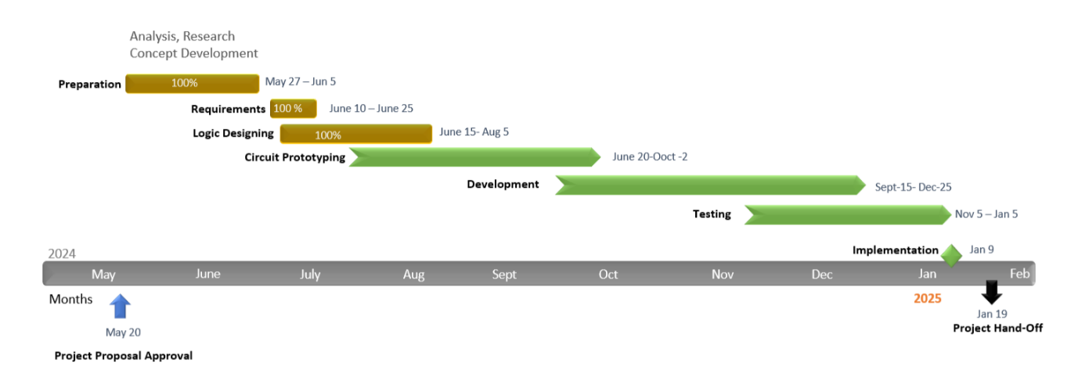

Figure 1: Timeline

# CHAPTER 2 LITERATURE REVIEW

## 2.1 REVIEW OF EXISTING SYSTEM

### 2.1.1 Livall MC1 Pro Helmet

The Livall MC1 Pro helmet is a smart helmet offering advanced features for rider safety and convenience. Key aspects include:

1. **Communication:** Built-in speakers and a microphone for hands-free phone calls and communication with other cyclists via Bluetooth.
2. **Safety:** SOS alert system sends emergency messages with GPS location during accidents. Fall detection sensors trigger alerts, and integrated LED lights enhance visibility.
3. **Comfort:** Lightweight, well-ventilated design with adjustable straps and padding for a secure fit.
4. **Smart Functions:** Music playback through built-in speakers and a walkie-talkie function for group communication.
5. **Battery Life:** Long-lasting battery with easy recharging, complemented by a mobile app for route tracking, ride data analysis, and settings customization.

**Limitations:** Potential improvements include sensor accuracy, extended battery life, and new features like alcohol detection and advanced fall detection.

This review of the Livall MC1 Pro provides insights into current smart helmet capabilities and areas for innovation in our Smart Helmet project. (Livall MC1 Smart full face helmet Black | Motardinn, 2023)

### 2.1.2 Tali iT C Smart Helmet

The Tali iT C smart helmet enhances rider safety and convenience with the following features:

1. **Communication:**
   1. Bluetooth connectivity for hands-free calls, music, and GPS.
   2. Built-in speakers and microphone.
2. **Safety:**
   1. SOS alert system for emergencies.
   2. LED lights synchronized with brake lights and turn signals.
   3. Fall detection sensors.
3. **Comfort and Design:**
   1. Lightweight, ergonomic design with good ventilation.
   2. Adjustable fit for various head sizes.
4. **Smart Functions:**
   1. Voice command control.
   2. Mobile app for route tracking and ride data.
5. **Battery Life:**
   1. Long-lasting, rechargeable battery.

**Conclusion:** The Tali iT C smart helmet is a strong example of current technology, guiding our Smart Helmet project's development to introduce innovative features for rider safety and convenience. (iT-C HELMET - TALI Connected, 2022)

### 2.1.3 Vata 7x1 Smart Helmet

The Vata 7x1 smart helmet integrates advanced features to enhance rider safety and convenience:

1. **Communication:**
   1. Bluetooth connectivity for hands-free calls, music playback, and GPS navigation.
   2. Built-in speakers and microphone for clear communication.
2. **Safety:**
   1. SOS alert system for automatic emergency notifications.
   2. Integrated LED lights for improved visibility.
   3. Fall detection sensors to trigger emergency alerts in case of accidents.
3. **Comfort and Design:**
   1. Lightweight and ergonomic design with adequate ventilation for comfort during long rides.
   2. Adjustable fit to accommodate different head sizes.
4. **Smart Functions:**
   1. Voice command functionality for hands-free control of helmet features.
   2. Mobile app integration for route tracking and ride data analysis.
5. **Battery Life:**
   1. Long-lasting rechargeable battery, ensuring readiness for extended rides.

**Conclusion:** The Vata 7x1 smart helmet exemplifies current smart helmet technology with its strong safety, communication, and convenience features. This review informs our Smart Helmet project, helping us develop innovative features that address the specific needs and challenges of modern riders. (X1 Smart LED HELMET, 2023)

### 2.1.4 Sena Impulse Smart Helmet

The Sena Impulse smart helmet integrates advanced features to enhance rider safety and convenience:

1. **Communication:**
2. **Bluetooth Connectivity**:
3. **Built-in Speakers and Microphone**:
4. **Safety:**
5. **DOT Certification**:
   1. The helmet is DOT certified, ensuring it meets safety standards for protective headgear​.
6. **Noise Control**:
   1. Features Intelligent Noise Control (INC) for passive and active noise reduction, enhancing auditory clarity and reducing distractions​.
7. **Smart Functions:**
8. **Voice Command Functionality**:
   1. Supports voice commands in multiple languages, allowing for hands-free control of helmet features​.
9. **Firmware Updates**:
   1. Equipped with WiFi for wireless firmware updates, ensuring the helmet stays up-to-date with the latest features and improvements​.
10. **Battery Life:**
11. **Long-lasting Rechargeable Battery**:
    * The helmet has a significant battery life, supporting extended use for Bluetooth communication and LED taillight. It also includes a convenient magnetic connector for charging​.

**Conclusion:**

The Sena Impulse smart helmet exemplifies current smart helmet technology with its strong safety, communication, and convenience features. This review informs our Smart Helmet project, helping us develop innovative features that address the specific needs and challenges of modern riders. By integrating advanced communication systems, ensuring high safety standards, and focusing on rider comfort and usability, the Sena Impulse sets a high standard in the market for smart helmets. (The Best Motorcycle & Action Sport Bluetooth Devices | Sena, 2024)

## 2.2 LITERATURE REVIEW

### 2.2.1 Introduction

Smart helmets have emerged as crucial innovations in enhancing rider safety and providing comprehensive monitoring and alert systems. Evolving from basic head protection gear, modern smart helmets now incorporate advanced technologies to ensure safety and improve the riding experience. Key features of these smart helmets include helmet detection, alcohol detection, fall detection alert, obstacle alert, over speeding alert, and engine overheating alert. Smart helmets are designed to cater to various needs, from casual riders to professional motorcyclists, offering a range of functionalities and technological integrations. The benefits of smart helmets include enhanced safety, real-time monitoring, accident prevention, and increased situational awareness. However, implementing these features poses challenges such as high development costs, technological integration complexities, ensuring user adoption, and maintaining data security. Despite these challenges, smart helmets play a significant role in advancing rider safety and are crucial in reducing road accidents and injuries.

### 2.2.2 Development of Proposed System

Smart helmets have revolutionized rider safety by integrating advanced monitoring systems and providing real-time alerts. Initially developed to provide basic head protection, smart helmets now offer comprehensive safety features, including helmet detection to ensure proper usage, alcohol detection to prevent drunk riding, fall detection alerts, obstacle alerts to prevent collisions, over speeding alerts to maintain safe speeds, and engine overheating alerts to prevent mechanical failures. These features are implemented through various sensors, microcontrollers, and communication modules. Smart helmets are available in different forms, catering to various user needs and preferences.

The primary advantages of smart helmets include enhanced rider safety and real-time monitoring capabilities. They provide automated alerts and notifications, significantly reducing the risk of accidents. This allows riders to focus on the road without being distracted by manual checks. Smart helmets also ensure accurate monitoring and help comply with safety regulations. Advanced analytics and reporting tools within smart helmets provide valuable insights for informed decision-making. Additionally, smart helmets enhance rider engagement by offering seamless integration with mobile devices and apps, providing easy access to personal information and safety features.

However, implementing smart helmets presents challenges such as high initial costs, integration complexities, managing technological changes, ensuring data security and privacy, and achieving user adoption through adequate training and support. As technology continues to advance, incorporating artificial intelligence and machine learning, smart helmets will further evolve, offering even greater potential to optimize rider safety and contribute to overall traffic safety.

## 2.2.3 Methodology

**Modular Development Approach**

The development of the Smart Helmet project follows a modular development approach, ensuring systematic and efficient progress by breaking the system into distinct, manageable modules. The product vision focuses on enhancing rider safety and convenience through IoT-enabled features. Core modules such as helmet detection, alcohol monitoring, fall detection, GPS tracking, and emergency messaging are identified to structure the project into logical units.

The modular approach begins with the design and development of foundational modules like helmet detection and emergency notifications, which serve as the system's backbone. Each module is developed independently, with clear goals and deliverables. Development phases include design, coding, testing, and integration, ensuring that every module functions optimally before being incorporated into the overall system.

Integration is performed incrementally as modules are completed, ensuring seamless interaction between different components of the system. This method minimizes risks by isolating potential issues within specific modules and allows for parallel development efforts, improving efficiency and scalability.

Testing is conducted at both module and system levels to verify functionality and reliability. Post-deployment, individual modules are monitored and maintained independently, enabling targeted updates and improvements without disrupting the entire system.

User feedback is collected for specific modules, guiding iterative refinements and ensuring the system evolves to meet user needs effectively. By adopting modular development, the Smart Helmet project ensures a streamlined, adaptable, and high-quality development process

. 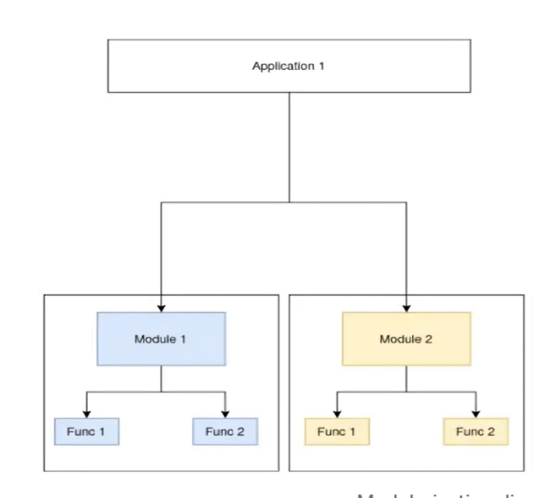

Figure 2: Modular Development (Korkut, 2023)

### 2.2.4 Comparison

Comparison between Vata 7x1, Tali iTc, Livall MC1 Pro Proposed System and smart helmet are presented below:

|  |  |  |  |  |
| --- | --- | --- | --- | --- |
| **Feature** | **Vata 7x1** | **Tali iTc** | **Livall MC1 Pro** | **Proposed System** |
| Helmet Detection | Basic | Advanced | Basic | Basic |
| Alcohol Detection | Yes | No | Yes | Yes |
| Fall Detection Alert | Yes | Yes | No | Yes |
| Obstacle Alert | No | Yes | No | Yes |
| Over Speeding Alert | Yes | No | Yes | Yes |
| Engine Overheat Alert | No | No | Yes | Yes |
| Customization | Standardized features | More customization options | Standardized features | No Customization |
| Scalability | Targets casual riders | Caters to professional riders | Suitable for all riders | Targets all types of riders with scalable features |
| Analytics | Basic performance metrics | Advanced safety analytics | Basic performance metrics | Comprehensive analytics on safety and performance |
| Total Cost of Ownership (TCO) | Generally lower | Can be expensive | Generally lower | Generally lower |

Table 1: Comparison between Vata 7x1, Tali iTc, Livall MC1 Pro and Proposed System

# CHAPTER 3 SYSTEM ANALYSIS

## 3.1 FUNCTIONAL REQUIREMENTS

1. **Helmet Detection System**
   1. The helmet is equipped with sensors to detect if the helmet is being worn.
   2. The system prevent the bike from starting if the helmet is not detected.
2. **Alcohol Detection**
   1. The helmet includes a sensor to measure the rider’s blood alcohol content (BAC).
   2. The system notifies the rider and prevent the bike from starting if the BAC exceeds a predefined limit.
3. **Fall Detection Alert**
   1. The helmet must have accelerometers and gyroscopes to detect falls.
   2. The system should detect reckless driving and alert the rider
4. **Obstacle Alert**
   1. The helmet must include sensors to detect obstacles in the rider’s path.
   2. The system should provide audible and visual alerts to the rider when an obstacle is detected.
   3. The system must have adjustable sensitivity to accommodate different riding conditions.
5. **Over Speeding Alert**
   1. The system should provide alerts to the rider when the speed exceeds predefined safe limits.
6. **Engine Overheating Alert**
   1. The helmet must integrate with the bike’s engine monitoring system to detect overheating.
   2. The system should provide alerts to the rider when the engine temperature exceeds safe limits.
7. **SOS Button**
   1. The helmet includes an SOS button that allows the rider to manually initiate an emergency alert in critical situations.
   2. The system sends a location-based emergency message to a designated contact through a mobile app, ensuring timely assistance.

### 3.1.1 Use Case Diagram

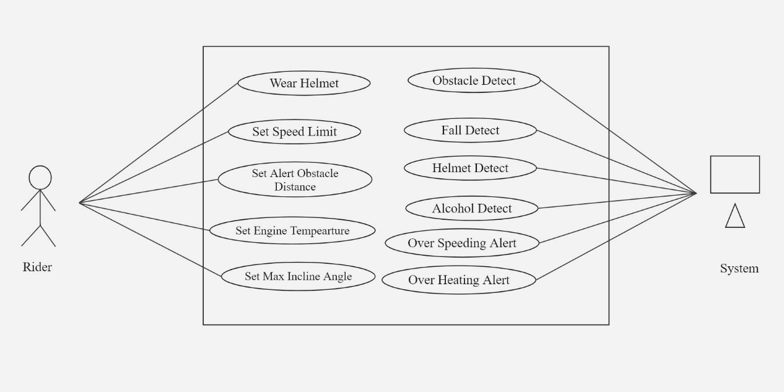

Figure 3: Use Case Diagram

## 3.2 NON- FUNCTIONAL REQUIREMENTS

1. **Performance**
   1. The system must provide real-time monitoring and alerts with a maximum delay of 1 second.
   2. The sensors must operate efficiently with minimal power consumption to ensure long battery life.
2. **Reliability**
   1. The helmet’s detection and alert systems must have an uptime of 99.9%.
   2. The system must be able to operate under various environmental conditions such as rain, heat, and dust.
3. **Usability**
   1. The user interface must be intuitive and easy to use for riders of all ages.
   2. The alerts must be clear and distinguishable even in noisy environments.
4. **Scalability**
   1. The helmet must support firmware updates to add new features and improve existing functionalities.
5. **Compatibility**
   1. The system should integrate seamlessly with different motorcycle brands and models.
6. **Maintainability**
   1. The system must be designed for easy maintenance and troubleshooting.
   2. The helmet must allow for easy replacement of components like sensors and batteries.
7. **Durability**
   1. The helmet and its components must be durable and able to withstand rough handling and impact.
   2. The system must be water-resistant and able to function in various weather conditions.

## 3.3 FEASIBILITY STUDY

The feasibility of the system has been studied from various aspects whether the system is feasible technically, operationally, and economically. After making an initial investigation, a feasibility study was carried out to check the system's workability. The different analysis of the system is carried out below:

### 3.3.1 Economic Feasibility

Economic feasibility assesses whether the smart helmet system is cost-effective and financially viable. This involves analyzing the initial development costs, ongoing operational expenses, and potential financial benefits.

1. **Initial Costs for Development**

The initial costs for developing the smart helmet system are detailed below:

|  |  |  |  |
| --- | --- | --- | --- |
| **Components** | **Price** | **Quantity** | **Price( NPR )** |
| ESP 32 | 700 | 1 | 700 |
| ESP 32 S3 | 1200 | 1 | 1200 |
| Buzzer | 4 | 20 | 80 |
| Nrf2401 | 400 | 2 | 800 |
| LED | 5 | 20 | 100 |
| Ultrasonic | 200 | 1 | 200 |
| MQ Sensor | 400 | 1 | 400 |
| Switch | 6 | 20 | 120 |
| Relay | 200 | 1 | 200 |
| BMS+ Battery | 500 | 1 | 500 |
| MPU6050 | 600 | 1 | 600 |
| Helmet | 5000 | 1 | 5000 |
| FSR | 1100 | 2 | 2200 |
| Miscellaneous | 2000 | - | 2000 |
| **Total** |  |  | **12300** |

Table 2: Cost Estimation for Components

1. **Cost-Benefit Analysis:** The potential benefits include market demand for advanced safety gear, potential reductions in accident-related costs, and potential insurance incentives for users. These factors indicate a positive return on investment over time.
2. **Revenue Generation:** Revenue streams include direct sales of smart helmets, recurring revenue from software updates and subscriptions, and potential partnerships with insurance providers or motorcycle manufacturers.
3. **Market Demand:** There is a growing market demand for smart helmets equipped with advanced safety features, driven by increasing concerns over road safety and regulatory requirements.

### 3.3.2 Operational Feasibility

Operational feasibility assesses whether the smart helmet system can be effectively integrated into existing operations and used by the target audience:

* **User Acceptance:** The helmet's design prioritizes user comfort, ease of use, and intuitive interface for seamless integration into riders' daily routines. Training and support programs will be developed to ensure users can maximize the helmet's functionalities.
* **Maintenance and Durability:** The helmet is designed to be durable, weather-resistant, and capable of withstanding typical wear and tear. Maintenance procedures are streamlined to ensure easy replacement of components like batteries and sensors.
* **Compatibility:** The smart helmet is designed to be compatible with various motorcycle models. It integrates smoothly with existing bike systems
* **Regulatory Compliance:** The project adheres to strict safety standards and regulations, ensuring legal compliance in target markets. Continuous monitoring of regulatory updates and certifications will be maintained throughout the project lifecycle.

### 3.3.3 Technical Feasibility

Technical feasibility evaluates whether the necessary technology exists to develop the smart helmet system and whether it can be implemented effectively:

* **Technology Availability:** Advanced sensors (for helmet detection, alcohol detection, obstacle alert, etc.), microcontrollers, communication modules (nrf), and software algorithms are readily available. Continuous advancements in wearable technology and IOT support the development of sophisticated safety features.
* **Integration and Scalability:** The smart helmet integrates multiple technologies into a compact design, ensuring seamless communication between sensors, microcontrollers, and the user interface. The system is scalable to accommodate future upgrades and enhancements as technology evolves.
* **Power Management:** Efficient power management ensures extended battery life for prolonged use. Low-power components and optimized software algorithms are employed to maximize energy efficiency without compromising performance.
* **Security Measures:** Robust security protocols, including data encryption and secure communication channels, protect user data from unauthorized access and ensure privacy compliance with global standards.

The feasibility study concludes that the smart helmet project is economically, operationally, and technically feasible. With a clear path for development, market acceptance, and regulatory compliance, the project is well-positioned to enhance rider safety, meet market demands, and achieve sustainable growth in the competitive safety gear market

## 3.4 PROCESS MODELLING

### 3.4.1 Context Diagram

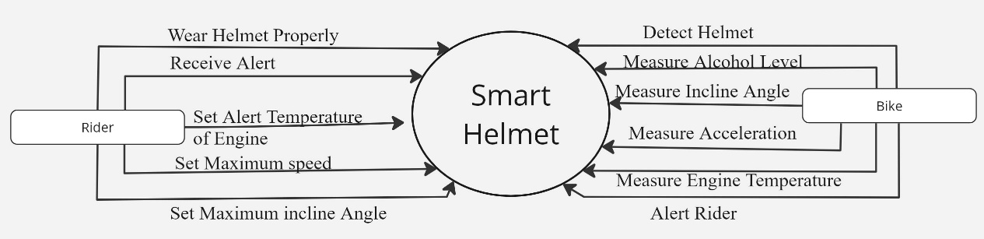

Figure 4*: Context* Diagram

### 3.4.2 Data Flow Diagram

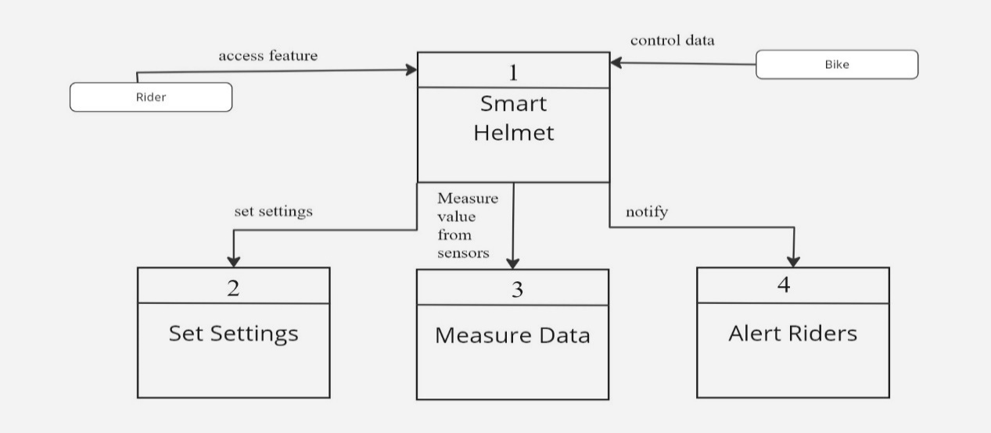

Figure 5*:*Level*-1 DFD*

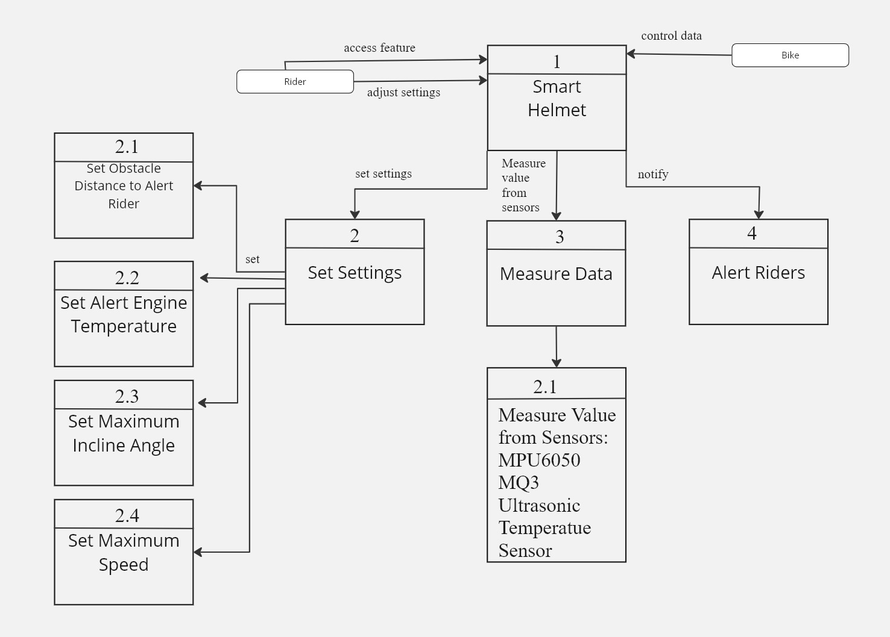

Figure 6*:* Level*-2 DFD*

## 3.5 LOGIC MODELLING

### 3.5.1 Decision Table

|  |  |  |  |  |  |  |
| --- | --- | --- | --- | --- | --- | --- |
| **Conditions** | **Rule 1** | **Rule 2** | **Rule 3** | **Rule 4** | **Rule 5** | **Rule 6** |
| Helmet Worn | True | True | True | True | True | False |
| BAC Level < Limit | True | False | True | True | True | Any |
| Fall Detected | False | False | True | False | False | Any |
| Obstacle Detected | False | False | False | True | False | Any |
| Speed Exceeds Limit | False | False | False | False | True | Any |
| Engine Overheating | False | False | False | False | False | Any |
| **Expected Result** | Engine On | Engine Off | Fall Alert | Obstacle Alert | Speed Alert | Engine Off |

## 

Table 3: Decision Table

### 3.5.2 Decision Tree

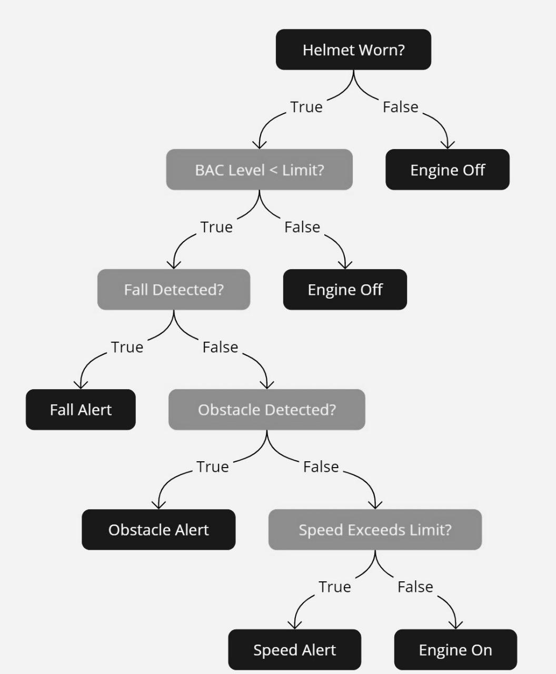

Figure 7: Decision Tree

### 3.6 Class Diagram

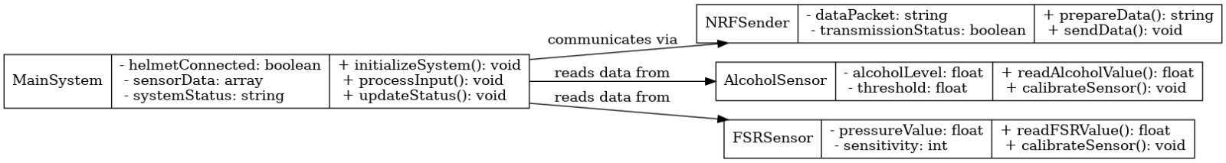

Figure 8: Class Diagram of Sender

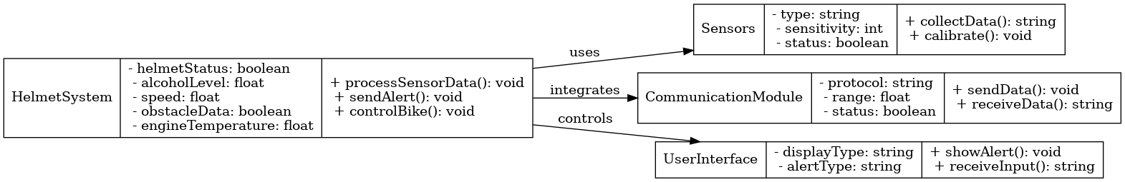

Figure 9: Class Diagram of Receiver

# CHAPTER 4 SYSTEM DESIGN

## 4.1 FLOWCHART

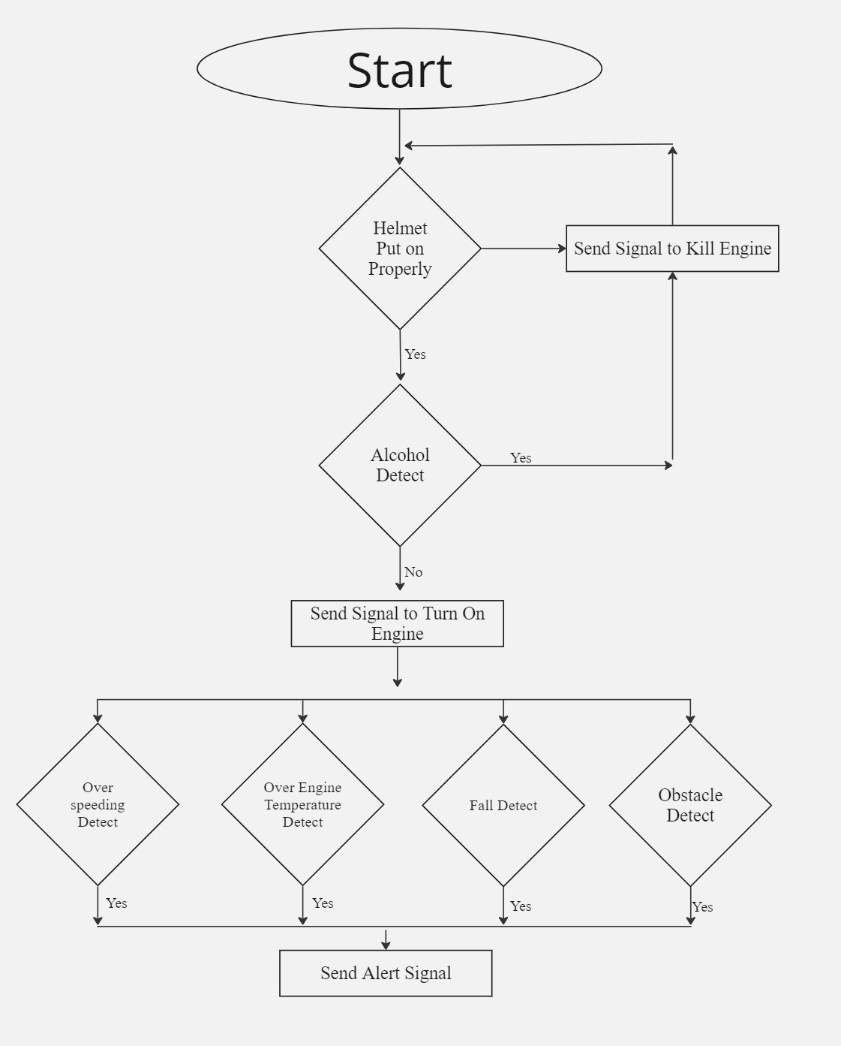

Figure 10: Flowchart

## 4.2 INPUT-OUTPUT DIAGRAM

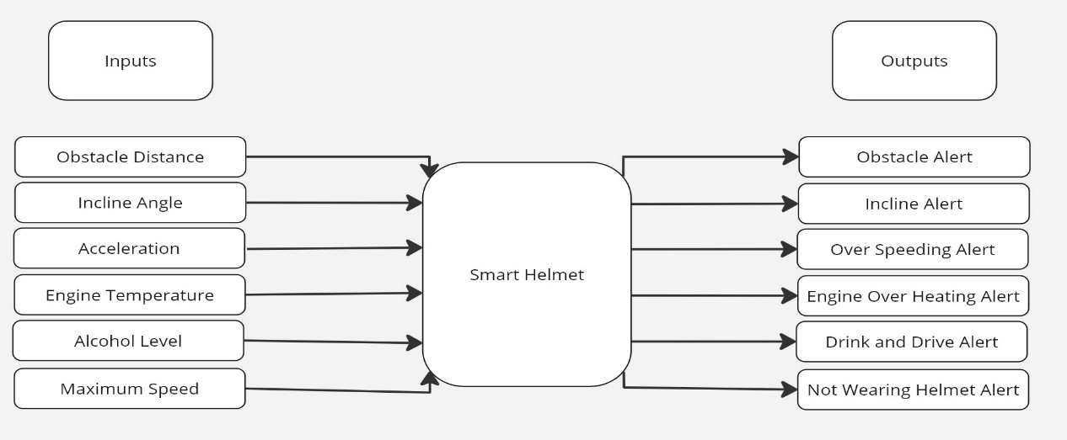

Figure 11*:* Input-Output Diagram

## 4.3 SYSTEM ARCHITECTURE DIAGRAM

**Components /Subsystem**

|  |  |
| --- | --- |
| 1. **Bike Controlling Unit** 2. ESP 32 3. Nrf24l01 4. DHT 11 5. Ultrasonic 6. MPU 6050 7. Single Channel Relay | 1. **Helmet Status Subsystem** 2. Arduino Uno 3. Nrf24l01 4. MQ sensor 5. Battery |

Power Controller

|  |
| --- |
| Relay Module |

*Turn power on and off*

*Communicates*

*Provides Sensor Reading*

*Center Controller*

Bike controlling Unit

ESP 32

Sensor

MPU6050

Ultrasonic

DHT 11

Communicator

|  |
| --- |
| Nrf24l01 |

*Communicates*

Helmet Unit

ESP 32 S3 As Controller

*Measure Value*

Sensors

FSR

MQ

Hardware Wrapper

|  |
| --- |
| Battery |
| BMS |

Nrf24l01

*Turn on/off*

Indicator

Message to mobile app

**Figure 12: System Architecture Diagram of Smart Helmet**

## 4.5 CIRCUIT DIAGRAM

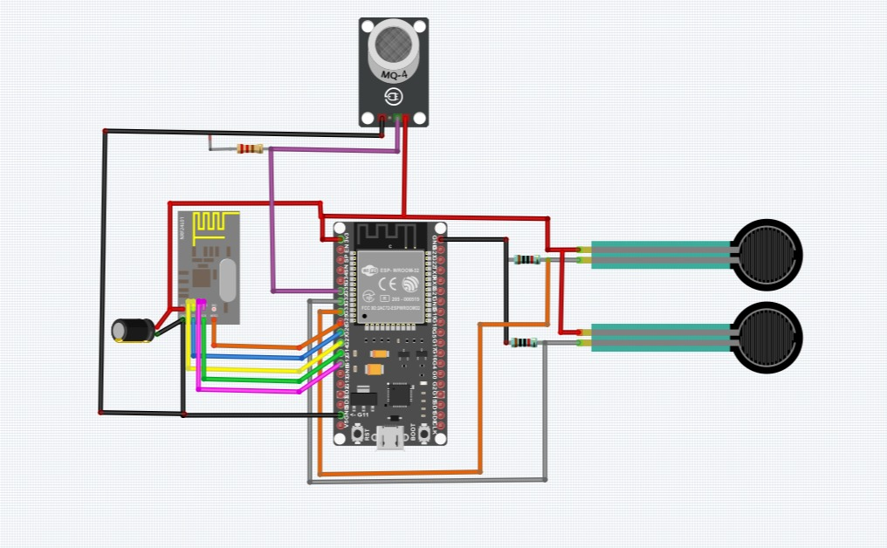

Figure 13: Circuit Diagram for Sender

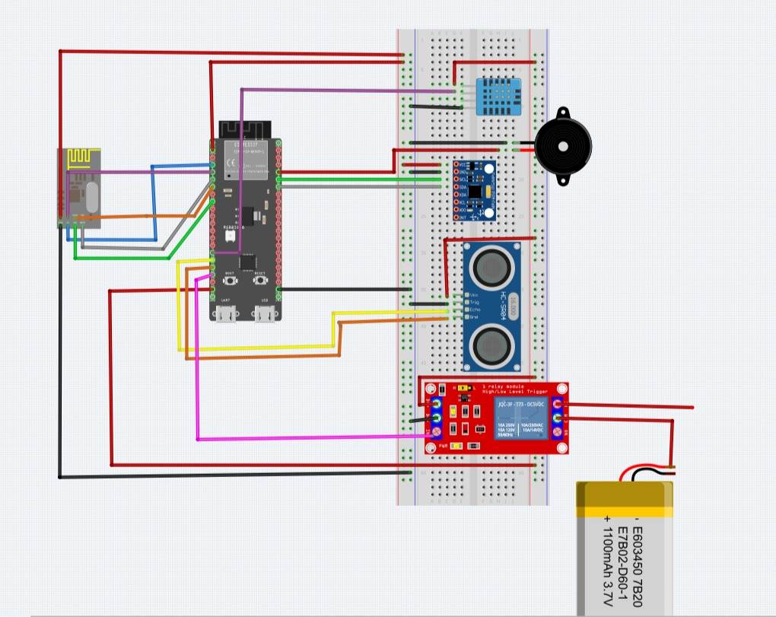

Figure 14: Circuit Diagram for Receiver

## 4.5 TOOLS USED

### 4.5.1 Hardware Used

### 4.5.1.1 Microcontrollers and Sensors

* ESP 32 S3
* Esp32 Dev module
* MQ3 sensor
* MPU6050 Gyroscope
* Ultrasonic sensor
* DHT 11
* FSR sensor

### 4.5.1.2 Communication Module

* NRF24L01 module
* ESP 32 BLE

### 4.5.1.3 User Interface Components

* LEDS
* Buzzer
* Button / Switches

### 4.5.2 Software and Programming Tools

* IDE: Arduino IDE
* Programming Language: C++
* Simulation: Tinker CAD , Fritzing
* Mobile App: MIT App Inventor

# CHAPTER 5 IMPLEMENTATION AND TESTING

## 5.1 IMPLEMENTATION

The implementation of the Smart Helmet system involved the integration of various hardware components, sensors, and software to create a functional prototype that enhances motorcyclist safety. The following steps were undertaken:

**5.1.1 Hardware Integration**

**Microcontrollers:** ESP 32 S3 and ESP32 Dev modules were selected as the central controllers for processing sensor data and managing communication.

**Sensors**: Key sensors included:

* MQ Sensor: For alcohol detection.
* MPU6050: For detecting falls and monitoring orientation.
* Ultrasonic Sensors: For obstacle detection.
* FSR Sensors: For helmet wear detection.
* Communication Modules: NRF24L01 was used to enable seamless communication between the helmet and bike systems.

Additional Components: LEDs and buzzers were integrated for alerts, while the Battery Management System (BMS) ensured efficient power management.

**5.1.2 Software Development**

**Programming**: The system was coded in C++ using the Arduino IDE. The software included modules for sensor data collection, signal processing, and alert generation.

**Sensor Calibration:** Each sensor was calibrated to ensure accurate readings under varying conditions.

**Communication Protocols:** The NRF24L01 communication module was configured to ensure reliable and low-latency data exchange.

**5.1.3 System Assembly**

The helmet-mounted sensors were connected to the ESP 32, while the bike-side components were interfaced with ESP32 S3.

A compact and robust design was achieved, considering ergonomic and weather-resistant requirements.

**Simulation and Validation**

Circuit designs were tested using Easy EDA and Tinker CAD to ensure proper connections and functionality before physical assembly. Mobile app was developed using MIT App inventor.

## 5.2 TESTING

The testing phase was crucial to evaluate the functionality, reliability, and performance of the Smart Helmet system. It was conducted in multiple stages:

**5.2.1 Unit Testing**

Individual components and modules, such as the MQ sensor, MPU6050, and ultrasonic sensors, were tested to validate their output accuracy and reliability.

**5.2.2 Integration Testing**

The interaction between sensors, microcontrollers, and communication modules was tested to ensure seamless data flow and real-time alerts.

**5.2.3 Functional Testing**

**Helmet Detection:** The system was tested to ensure the bike would only start when the helmet was properly worn.

**Alcohol Detection:** Various breath samples with different alcohol concentrations were tested to confirm accurate detection and bike lock functionality.

Fall Detection: Simulated falls were performed to verify the triggering of alerts.

**Obstacle Detection:** Objects were placed at varying distances to test the responsiveness of the ultrasonic sensors.

**Over Speeding Alert:** Speed thresholds were configured, and the system's ability to provide timely alerts was evaluated.

**Engine Overheating Alert:** The system's response to simulated overheating scenarios was validated.

**5.2.4 Performance Testing**

Real-time monitoring and alert generation were evaluated to ensure delays did not exceed 1 second.

The helmet’s battery life and power efficiency under continuous operation were tested.

**5.3 Results and Observations**

1. The Smart Helmet system successfully met all functional requirements, providing reliable safety features such as helmet detection, alcohol detection, and obstacle alerts.
2. Minor issues, such as sensor inaccuracies in extreme weather conditions, were identified and addressed through recalibration.
3. The system demonstrated high user acceptance, with testers praising its intuitive design and practical safety features.

This robust implementation and comprehensive testing ensured that the Smart Helmet is a reliable solution for enhancing motorcyclist safety.

# CHAPTER 6 CONCLUSION

## 6.1 CONCLUSION

The development and implementation of the Smart Helmet system present a significant advancement in enhancing rider safety and convenience through the integration of advanced IOT technologies. The comprehensive review of existing smart helmet models such as the Sena Impulse, Tali iT-C, and Livall MC1 Pro, along with the proposed system, highlights the strengths and potential areas for innovation.

The proposed Smart Helmet system incorporates critical safety features like helmet detection, alcohol detection, fall detection, obstacle alert, over-speeding alert, and engine overheating alert, leveraging advanced sensors and communication modules. These features are designed to provide real-time monitoring and alerts, thereby significantly reducing the risk of accidents and improving overall rider safety.

In conclusion, the Smart Helmet project is poised to set a new standard in the market for rider safety gear, combining robust safety features with rider comfort and usability. By addressing the specific needs and challenges of modern riders, the Smart Helmet aims to contribute substantially to road safety and the broader goal of reducing road accidents and injuries​

## 6.2 FUTURE ENHACEMENT

Future enhancement includes following features:

1. **Compact Design:**

* Further development will focus on minimizing the size of internal components, integrating sensors seamlessly into the helmet, and improving ergonomics. This will make the helmet lightweight, more comfortable, and suitable for prolonged usage.

1. **Cost Reduction:**

* Optimizing the hardware design and exploring mass production strategies will help in reducing the overall manufacturing costs, making the Smart Helmet affordable and accessible to a wider audience.

1. **More User Control and Freedom:**

* Future iterations will include customizable features, allowing users to tailor settings such as sensitivity of sensors, types of alerts, and levels of automation based on their preferences.

1. **Enhanced User Interface (UI):**

* "Improvements in the UI will include integrating a smartphone app with an intuitive dashboard for real-time monitoring, notifications, and feature control. Advanced options like voice commands or a heads-up display (HUD) can further elevate user experience."

These future enhancements can significantly improve the utility, safety, and user experience of the smart helmet, making it a comprehensive solution for modern motorcyclists. The focus should always remain on enhancing rider safety and convenience while minimizing distractions and maintaining regulatory compliance.

## 6.3 REFERENCE

1. *iT-C HELMET - TALI Connected*. (2022, 5 8). Retrieved from TALI Connecte: https://taliconnected.com/helmet/
2. Korkut, T. (2023, Aug 27). *Excelling in Software Development with Scrum Methodology* . Retrieved from blog.stackademi: https://blog.stackademic.com/excelling-in-software-development-with-scrum-methodology-part-2-e2d0b29437ce
3. *Livall MC1 Smart full face helmet Black | Motardinn*. (2023, 2 14). Retrieved from Tradeinn | Online shoppen: Sport, Mode, Technik und DIY: https://www.tradeinn.com/motardinn/en/livall-mc1-smart-full-face-helmet/140449689/p
4. *The Best Motorcycle & Action Sport Bluetooth Devices | Sena*. (2024, 07 11). Retrieved from Sena: https://www.sena.com/product/impulse/
5. *X1 Smart LED HELMET*. (2023, 07 11). Retrieved from VATA7: https://shop.vata7.com/products/x1-smart-led-helmet

## 6.4 APPENDIX

## 6.4.1 Prototype Image

## 

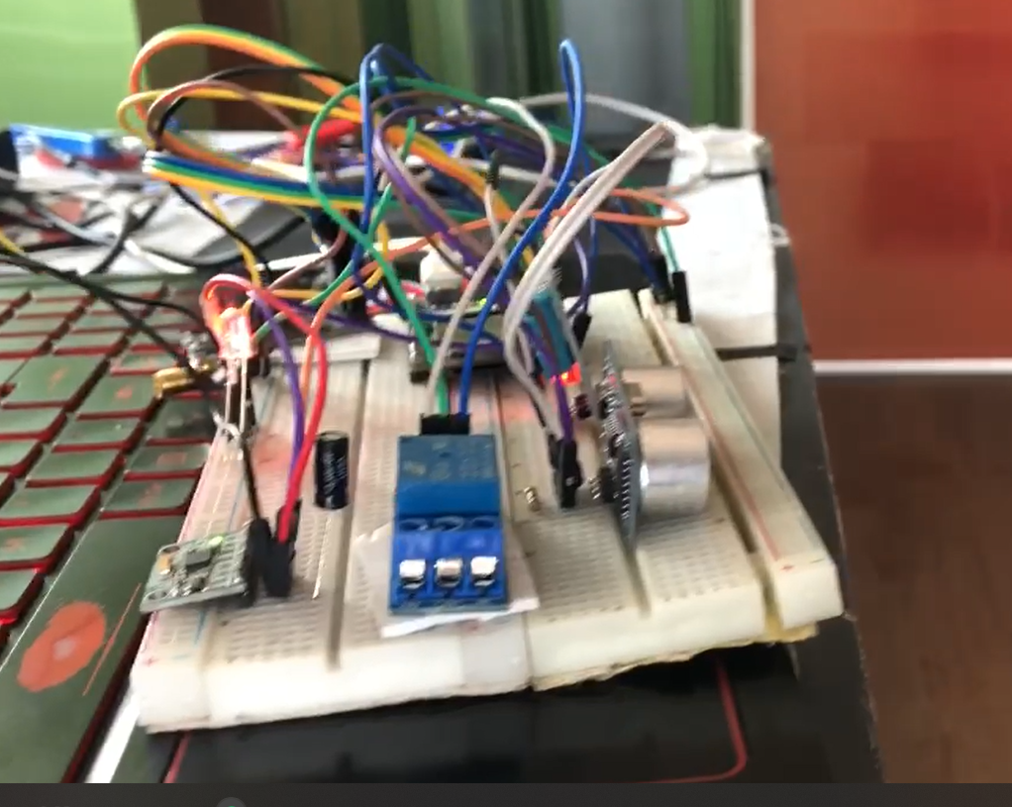

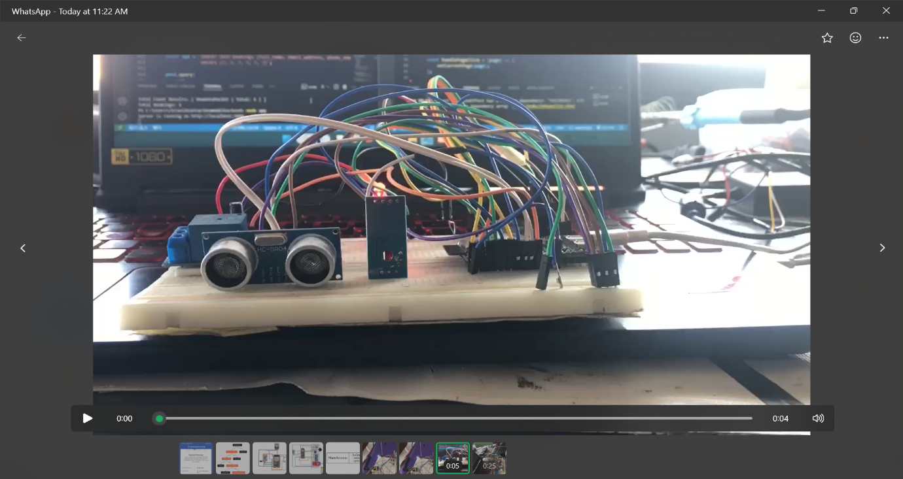

Figure 15: Prototyping in Breadboard

## 6.4.2 Circuit Board

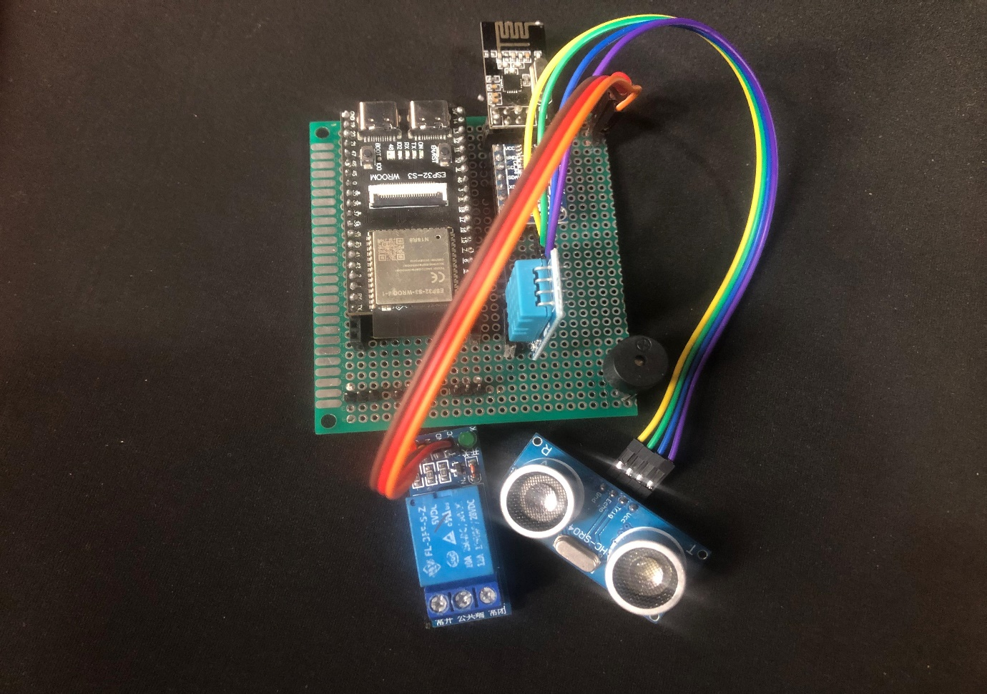

Figure 16: Circuit For Receiver

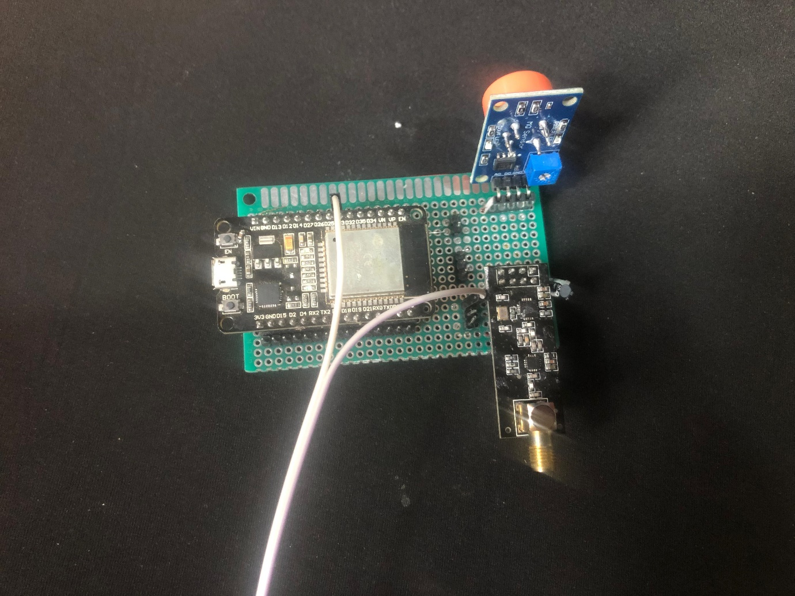

Figure 17: Circuit for Sender

## 6.4.2 Mobile App

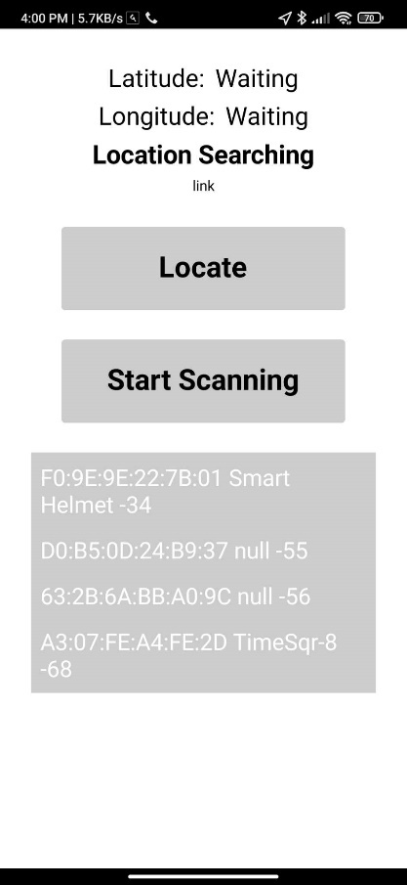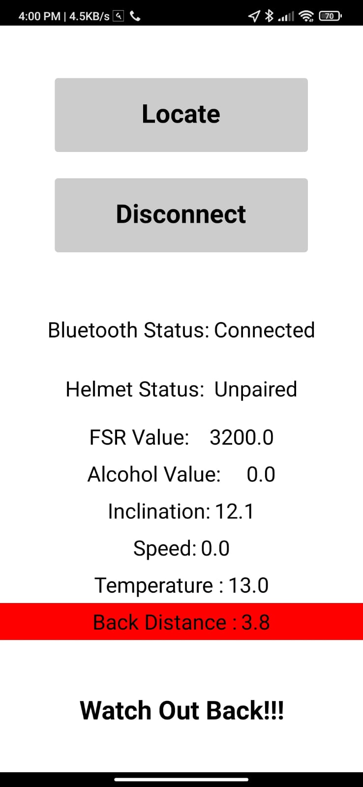

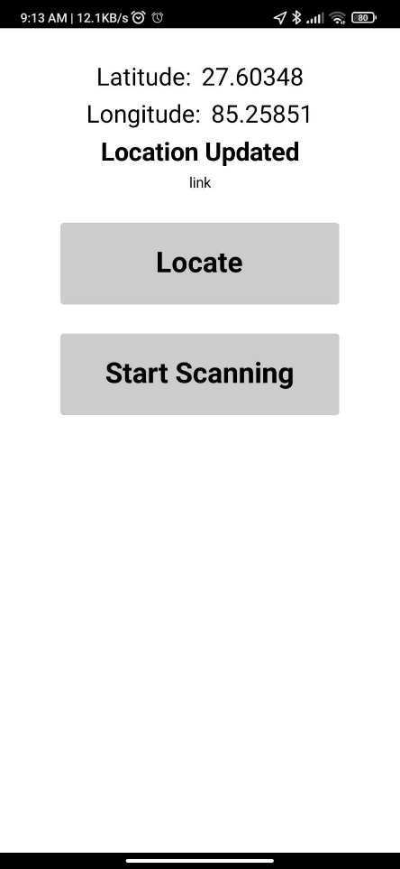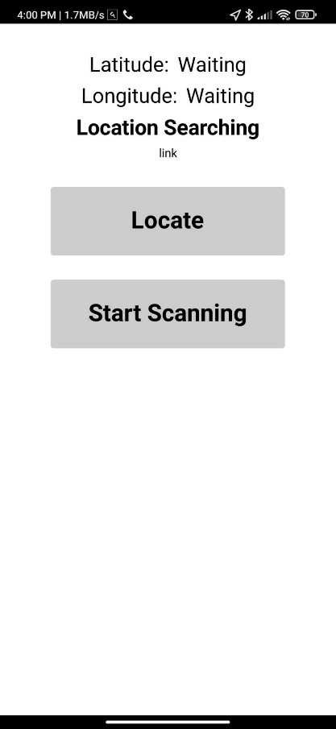

Figure 18: Mobile Interface to Show Data

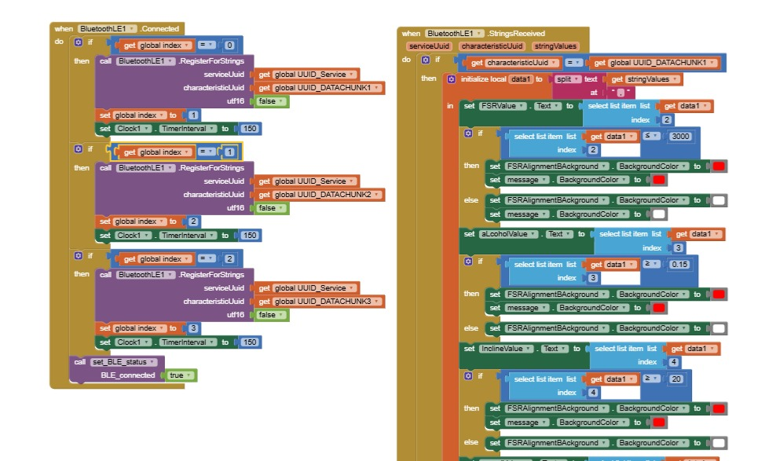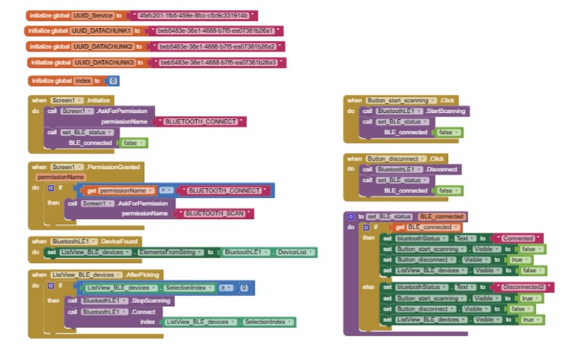

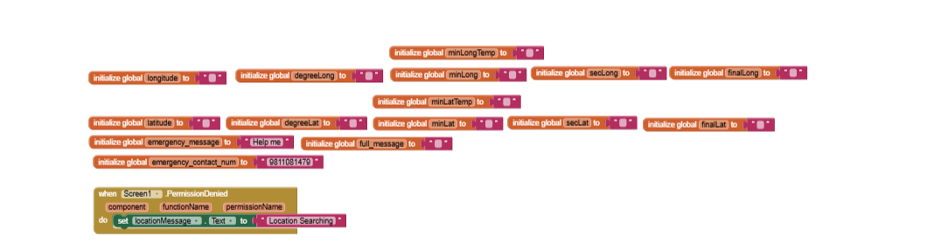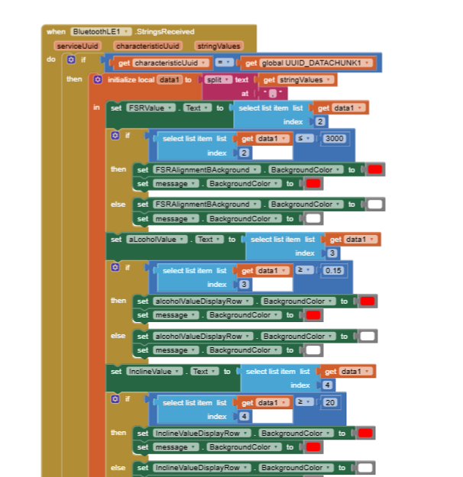

Figure 19: Block Diagram Code of Mobile App